**Central Tendency:**

T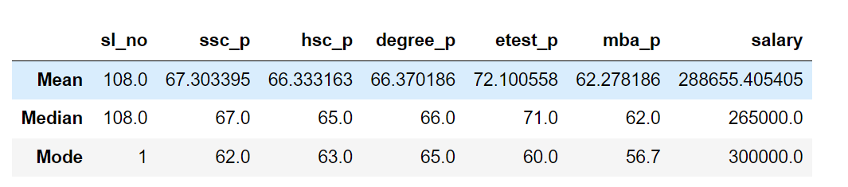

**Mean:**

* The **mean score** for SSC (Secondary School Certificate) is **67.3%**, while the **HSC (Higher Secondary Certificate)** and **Degree** means both stand at **66.3%**.
* The **E-test score** is **notably higher than the mean**, at **72.1%**.
* The **MBA score** has a **mean** of **62.2%**.
* The **mean salary** associated with these educational metrics is **288,655.41**.

**Median:**

* **The median score** for SSC (Secondary School Certificate) is **67.0%,** while the **HSC (Higher Secondary Certificate)** is **65%** and **Degree**  stand at **66%.**
* **The E-test score** is **notably higher than the median,** at **72.1%.**
* **The MBA score** has a **median** of **62.0%.**
* **The median salary** associated with these educational metrics is **265000.0.**

**Mode:**

* **The mode score** for the SSC (Secondary School Certificate) is **62.0%,** while the **HSC (Higher Secondary Certificate) has a mode of 63%,** and the **Degree mode stands at 65%.**
* **The E-test score** is aligned with the mode**, at 60%.**
* **The MBA score**, with a mode below average**, is 56.7%.**
* **The mode salary** associated with these educational metrics **is 300,000.0.**